Review for Quiz: Chapter 13 States of matter
- Explain the three main assumptions of the Kinetic Theory of Gases.
- Change 1325 kPa to atm.
- Change 2650 mm Hg to kPa and atm.
- What pressure, in kilopascals and in atmospheres, does a gas exert at 885 mm Hg?
- Convert the following pressures to kilopascals: a) 0.90 atm b) 100 mm of Hg.
- What the abbreviation STP represent? Specify the values of T & P.
- What is significant about temperature absolute zero?
- Use the graph to answer each question:

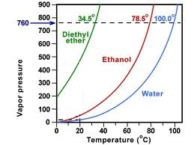
- What is the vapor pressure of water at 60ºC?
- At what temperature is the vapor pressure of water 500 mm of Hg?
- Indicate in the graph ( on the x axis) the boiling point of each of the substances.
- How the allotropes of an element differ? Mention two allotropes of carbon.
- What phases are in equilibrium at a substances melting point? In the boiling point?
- What is meant by “sublimation”? Mention two examples of substances that sublime at room temperature.
- What is meant by a phase diagram?
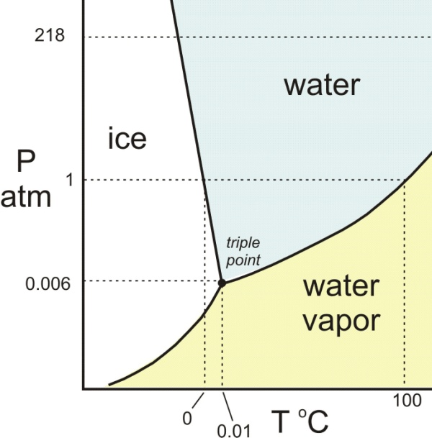
- Based on water’s phase diagram:
a) what the curving line that separate the different phases describes?
b) What is known as water triple point?
c) Specify water’s temperature and pressure at the triple point.
d) Indicate in the graph approximately: * melting point of water at 120 kPa. ** Melting point of water at 50 KPa.
***Boiling point of water at 120.0 KPa **** Boiling point of water at 50.00 kPa

