Practice. Chapter 13.4 Changes of State. Page 436. Name_________________________Period____Date______

- What is meant by “sublimation”? Mention two examples of substances that sublime at room temperature.
- Would you expect a substance that sublimates at room temperature to be a molecular substance or an ionic substance?
- Explain why a liquid stays at a constant temperature while is boiling.
- Refer back to figure 13.9 page 429 to answer the following questions.
a) What is the normal boiling point of ethanoic acid?
b) Which liquid has the highest vapor pressure at 40ºC?
c) At standard atmospheric pressure, which of the substances are in the gaseous state at 70ºC?
d) How would the pressure on ethanol and on ethanoic acid have to change for these liquids to boil at 100ºC?
e) Mount McKinley in Alaska is the tallest peak in North America at 6194 m. The atmospheric pressure at its peak is 44 kPa. What is the boiling point of water at the peak of Mount McKinley?
- Describe the evaporation process, vapor pressure and boiling point.
- Why is the equilibrium that exists between a liquid and its vapor in a closed container called a dynamic equilibrium?
- Why do different liquids have different normal boiling points?
- Describe what happens when a solid is heated to its melting point.
- Explain why molecular solids usually have a lower melting point than ionic solids.
- What is meant by a phase diagram?
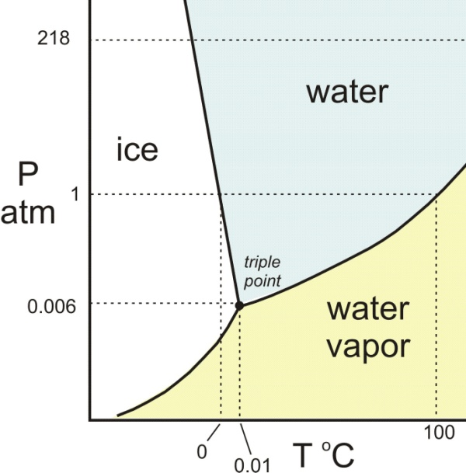
Based on water’s phase diagram:
a) what the curving line that separate the different phases describes?
b) What is known as water triple point?
c) Specify water’s tem and pressure at the triple point.
d) Indicate in the graph approximately: * melting point of water at 120 kPa. ** Melting point of water at 50 KPa.
***Boiling point of water at 120.0 KPa **** Boiling point of water at 50.00 kPa

